**Model Development Phase Template**

|  |  |
| --- | --- |
| Date | 21 June 2025 |
| Project Title | Classification of Arrhythmia by Using Deep Learning with 2-D ECG Spectral Image Representation |
| Maximum Marks | 4 Marks |

**Initial Model Training Code, Model Validation and Evaluation Report**

The initial model training code will be showcased in the future through a screenshot. The model validation and evaluation report will include classification reports, accuracy, and confusion matrices for multiple models, presented through respective screenshots.

**Initial Model Training Code:**

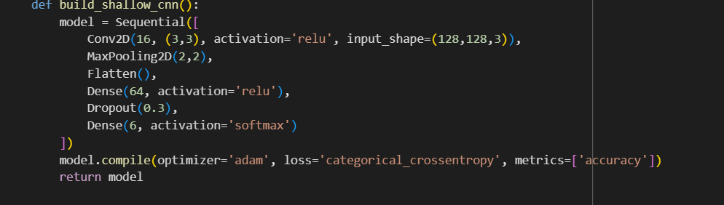

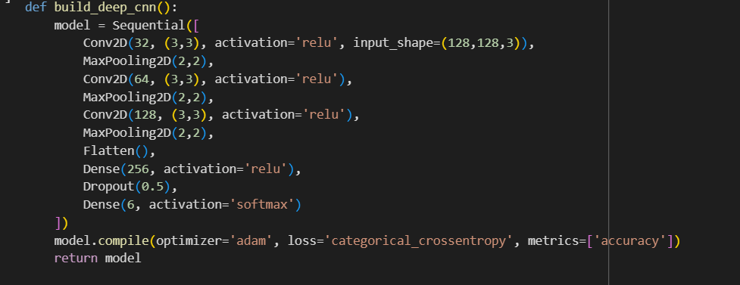

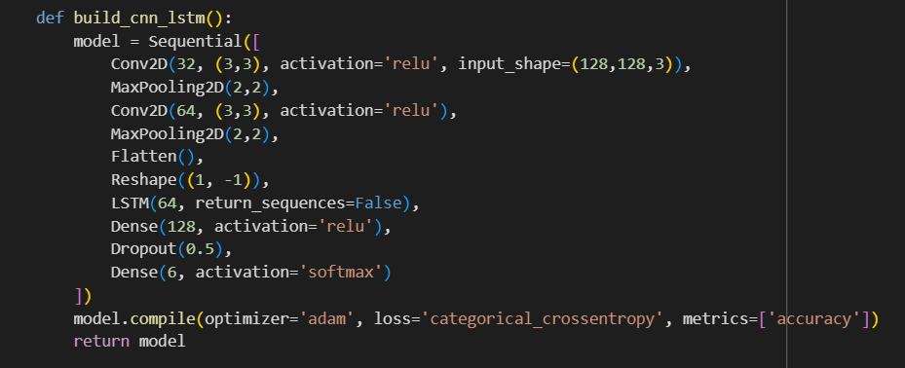

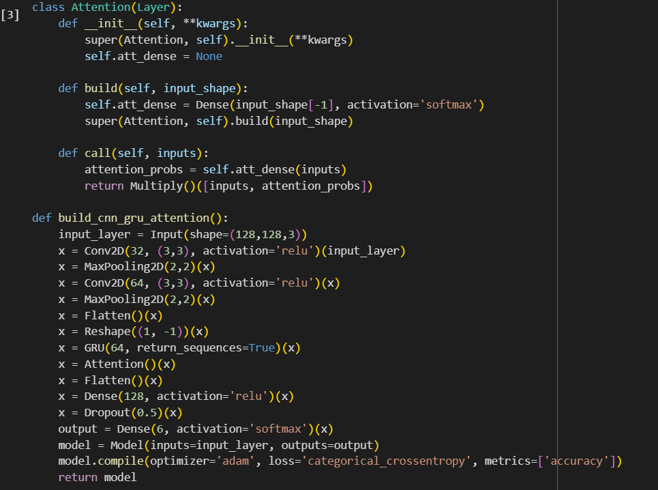

**Model Validation and Evaluation Report:**

|  |  |  |  |
| --- | --- | --- | --- |
| MODEL | CLASSIFICATION REPORT | F1 SCORE | CONFUSION MATRIX |
| Shallow CNN |  | 67% |  |
| Deep CNN |  | 91% |  |
| CNN with LSTM |  | 80% |  |
| CNN with GRU |  | 60% |  |